# Report: Analysis Dedola, Lippi (2005)

## Introduction

Back in 1963, the publication of the milestone A Monetary History of the United States, (Friedman and Schwartz) set the path for a flourishing literature about the study of the macroeconomic impact of monetary policy. A common story about the functioning of monetary policy is now days established and taught in any entry level course of economics. The central bank is assumed to leverage various tools in order to influence the short-term interest rate impacting the cost of capital. Consequently, investment decisions and the consumption of durable goods shift. Finally, this variation in aggregate demand propagates to production. However, as Bernanke and Gertler (1995) clearly emphasize, this story is incomplete. Empirical studies of the macroeconomic impact of monetary policy have identified recurrent quantitative as well as temporal unintuitive phenomena for which the textbook story fail to account for. For instance we observe that monetary tightening, despite impacting short-term interest rates, yield sharp decrease in the purchase of long-lived assets (housing, durable goods) which should primarily rely on long-term rates. Another puzzle is the reaction timing of business investment and inventories which seem to sharply decline only months after the monetary tightening, when short term interest rates have already leveled back to their original state.

Those observations are at the origin of the emergence of the credit channel theory which provides additional tools to understand more deeply the underlying mechanism of monetary transmission. Many empirical papers about the monetary transmission mechanism have then provided compelling illustrations of the explicative power of the credit channel theory. In our opinion, the paper written by Dedola and Lippi (2005) The monetary transmission mechanism: Evidence from the industries of five OECD countries typically falls into this category.

Dedola and Lippi (2005), the paper we have chosen to analyze, is the second version of an original work first published in 2000. The authors’ point is to emphasize the benefits of analyzing micro industrial level data in order to better understand the monetary transmission mechanism. It is structured into two parts. Dedola and Lippi start by quantitatively documenting the homogeneous nature of cross-country macroeconomic reactions to monetary policy shocks and adversely how similarly heterogeneous cross-industry responses are across the spectrum of countries. The paper then investigates how empirical regularities relate to theoretical findings concerning the monetary transmission mechanism. This not only helps to assess the robustness of the quantitative findings made, but also provides a test of the explanatory power of the credit channel theory. Hence, this empirical paper has been of primal interest for two reasons. Firstly, following the tradition of previous empirical studies of monetary policy, it makes use of simple but powerful quantitative tools: structural VAR and regressions. This allows for highly interpretable, easily comparable and manageably replicable results. Secondly, this paper illustrates the explanatory power of credit channel theory, and more specifically that of the balance sheet channel approach. In fact, we will see that this theory about the monetary transmission mechanism seems to account for much of the cross-industry heterogeneous response found in this paper.

Therefore, we intend to first present the main findings of this paper and emphasize how they relate to the credit channel paradigm, before presenting the quantitative approach and tools used by the authors. Finally, we will comment on the replication part we made using matlab. We studied the level of homogeneity among output responses of euro area countries, when hit by an unanticipated supra national monetary shock. Using what we learned from our empirical work, as well as the enlightening results proposed by Dedola and Lippi, we conclude by formulating different thoughts about the challenges that face the literature.

## Part 1 - Main Results of the paper

The leitmotiv of this paper is to express the importance of disaggregated data in better understanding the macroeconomic effects of monetary policy. The data analysis of five OECD countries establishes that at an aggregated data level, the impact of monetary policy throughout developed countries is quite uniform whereas within national economies cross-industry responses can be highly disparate. Looking at an aggregated level, comparing country to country, is like making use of our textbook theory of monetary policy; it only helps grasping part of the picture. While among developed countries the tools used to apply monetary shocks are similar and impact economies which are similarly structured (industry share etc.), industries among those countries present striking differences.

Hence, looking at disaggregated industry-level data, the paper identifies two radically different sectoral responses to monetary shock. Firstly, Dedola and Lippi pinpoint a group of industries which little react to a monetary shock, displaying only a lagged and minimal decline in output. For instance, if we average over the 5 OECD countries studied, the Food industry reaches a maximum decline in output of about 0.3% in the 12 to 36 months following a 1 percentage point increase in the short-term rate. In contrast, the motor vehicle industry displays a sharp decrease in output of at least 1.24% across the board. This second type of industry notably seems to specialize in the production of durables, and consequently experiences a sharper contraction of demand. Controlling for country specificities, the authors show that those heterogenous industry responses remain significative, signaling that no or few country effects are at the origin of such variabilities. But how then can we account for those disparities?

There is “a set of factors” that seem to “amplify and propagate conventional interest rate effects”. This is precisely how Bernanke and Gertler, in their paper Inside the black box: the credit channel theory of monetary policy transmission (1995), define the credit channel theory. According to this theory, monetary shocks induce endogenous changes in the external premium, which is the difference between the cost of resorting to external financing (bank loans) and internal financing. A major way this could occur is by the “balance sheet channel”. Basically, a monetary tightening can directly impact the balance sheets of firms which rely on short-term debt to fuel supply (inventory purchases, working capital etc.). By increasing the interest rate expenses, the monetary shock reduces the net cash flows and worsens those firms’ financial positions. It then becomes harder for them to borrow, since their finance premium has increased. Spending and investment decision shifts then lead to inventory clearance followed by output contraction. Another effect of the balance sheet channel is indirect. Monetary tightening can also possibly depress the income statements of many consumers, postponing spending, notably on durable goods. Consequently, firms experience a decrease in demand while the fixed costs and quasi-fixed costs remain stable in the short-term. This results in depressing even further the borrowing capacities of firms and hence strengthening the activity contraction. Some industries are more impacted than others by this balance sheet channel. For instance, an industry composed of a majority of small sized firms, or firms with lower collaterals, is an industry for which the finance premium will naturally be higher. Many studies have in fact shown that smaller firms tend to face higher credit constraints. As expressed by the credit channel theory, this credit constraint is worsened in the wake of a monetary tightening. Parallelly, industries producing durables experience quicker and steeper drops in demand, which is made more elastic by the degradation of income statements and the increase in cost of capital for households. Hence, clear industry specificities seem to account for variations in sectorial sensitivity to monetary shock.

Using those insights from the credit channel theory, Dedola and Lippi regressed the response to monetary shock over industry specific characteristics. The authors’ results were striking. They found that greater borrowing capacity (bigger firm size, higher leverage) tempers the output effects of monetary policy. On the other hand, industries which produce durables and rely heavily on working capital experience worsen output effects when hit by an unanticipated monetary shock. As the authors summarize: we observe that “sectoral differences in the transmission mechanism” appear to be “systematically related to differences in working capital requirements, industry demand features and the fraction of credit constrained firms”. As is always the case when performing regression analysis, results may be subject to omitted variable bias (OVB). Some hidden factors may for instance be at the root of the observed correlation between output sensitivity and firm size. However, the usage of disaggregated data allows for a robust set of controls which can contribute to obliviating the risk of OVB.

As a consequence, monetary transmission mechanisms, unquestionably, cannot be fully understood without taking a disaggregated view. Not only does the usage of micro-data helps assessing how heterogeneous sectoral responses are to monetary shock, but it also ensures the production of robust results and provides validation for theoretical findings about the monetary transmission mechanism.

## Part 2 – Quantitative tools overview

The underlying logic is here that if a same monetary policy shock has different consequences on two sectors, they must exhibit differences affecting the operation of channels. The methodology applied is then to identify the shocks, to measure their impact on several countries, and on different sector on those countries (in order to suggest a cross-country heterogeneity, but the cross industry in cross-country homogeneity), and attribute differences to structural characteristics, which could affect the transmission channel. In this paper, the authors used then two main tools. First, the structural VAR, to measure the impact of the shocks on several variable (and then compute their elasticity to the shock). Secondly, the regression, to model the nature of the link, between variables. The shocks are considered as exogenous, and even if the authors do not build a theoric model, but they base on economic assumptions the construction of their tools. Finally, we notice that the authors used the sample of monthly data from 1975 to 1997.

The SVAR, and the impact of monetary policy shocks on several variables:

In the first part of the paper Dedola and Lippi build several SVAR in order to evaluate the level of heterogeneity of cross-country responses to monetary shocks. Vector auto regressions are models that study the relation over time between several variables.  The VAR must become “structural” in order to allow economic knowledge takeaways. In fact, monetary policy in economies with effective institutions mostly reacts endogenously to variation in outputs or prices (*depending on the central bank’s duties*). However, better understanding the monetary transmission mechanism requires us to constrain our analysis to the exogenous part of monetary policy i.e., the monetary shock. This is when structural VAR comes in handy. Having a structural VAR means that we allow for contemporaneous relations between the variables of the model. Solving it often requires making some assumptions about such contemporaneous relations. Those assumptions allow for economic interpretation in two ways: first, they are equivalent to setting some restrictions in the model, enabling the identification stage to occur. Identifying an SVAR means that we can express the residuals of the initial system as a linear combination of weak white noise shocks. Secondly, it permits to model economically relevant relations between variables. For instance, when studying how the exogenous component of monetary policy impacts industrial production, it makes sense to assume that short term interest rates can react contemporaneously to disturbances in industrial production. On the other hand, industrial production evidently only reacts with a lag to manipulation of exchange rates. In other words, we restrict the contemporaneous effect of interest rates on industrial production to a null effect.  These are reasons why SVAR allows for the extraction of the monetary shock from the endogenous components of monetary policy and make the interpretation of impulse responses possible.

One of the main advantages of using this Structural VAR is that the ordering of the variable (they distinguish the variables which should respond to the policy shock with a delay, and the variables which should be directly affected) don’t seem here so significant (it could have been). The chose ordering is not the same, across countries, and depends on some economic knowledge assumptions. But as said by the authors, even if another order could be chose (with other economic assumptions), here, the impact on industrial production doesn’t change, if the industrial production is considered as a variable which respond with a delay or not.

First, the SVAR is used to study the impact of monetary policy on each country of the sample (USA, the UK, France, Germany and Italy), and to document the homogeneity of cross-country reaction to these shocks. The way to do it is to study the impact on all the following variable: industrial production, consumer price index, commodity price index, short term interest rate, and the monetary aggregate, and … As said, they observe an across country heterogeneity.

But the SVAR is also used to study the impact of a shock on sectors industrial data (and not only on the global industrial production of a country) in these 5 countries. To study the impact of monetary policy shock on industry sectors, the authors add to the previous variables the production index of several industries. Results of the impact are still model trough impulse response function. But in the case of the several industrials sectors, author summarized the results of their impact trough elasticities of the several industrial sectors to shocks.

Study of correlation, and using of Linear regression, to study the reason of the results:

The correlation allows to know in what extend two variables are linked, while the linear regression allows to know the nature of the link with one or many other variables. Depending on correlation coefficients (if variables seem to be correlated), author study then the nature of the relation trough the regression. The authors use many correlation coefficients of elasticity: first, to compute the correlation allows to know in what extend the effect of the shock depend particularly on the kind of measure of impact (and then, on the kind of elasticity). Indeed, the elasticity of industrial output to a monetary policy shock does not seem so dependant of the time which the authors took in account. The second usage consists in suggesting cross industry similarity, by using correlation of disaggregated data, with the impact of monetary policy shocks. The regression allows here to qualify particularly effects of monetary policy shocks on industrial firms, based on the industry sector, and several qualities of the firms. It consists to use the output effects of monetary policy (measured by the elasticity) and several industry characteristics: the authors use a “durability dummy” and several set of indicators, which allow to have an idea of frictions. Those characteristics are studied in order to evaluate the transmission channel, that they could affect. Finally, the response of sectoral production to the shock is related to product durability, financial requirements, borrowing capacity, and firm size. The studied characteristics can also allow to study two views: the demand channel, and the cost channel. In the case of disaggregated data, the regression is particularly interesting: author can change value of chose indicator. These indicators allow to verify rigorously the fact that cross country heterogeneity in the impact of shocks is due to the cross-country difference in the industry.

To verify the robustness of the results, the authors used several methods:

* Doing the VAR by Choosing a shorter sample, by paying attention to keep periods with historically manifest changes: for example, take in account of the period hard ERM and pre-EMU to reestimate the European data, due to the change in the monetary policy in the European union, and precisely to the link between currencies.
* Choosing control variables, and using alternative identifying assumption: these variables are added in the VAR. The objective is to see if the effect on previous variable is still the same, by adding some variable which could have an effect on other variable of the sample. Those control variables are considered as “first” in the order of the VAR order, then as the more exogenous. To choose them depends on economic and empirical knowledge. Indeed, they add a short-term dollar rate for Germany, and a German short-term rate for France, considering that France monetary policy must be influenced by Germany, while German monetary policy must be influenced by the US.
* Changing the identification scheme, by moving the industrial production in the set of variables which are directly affected, in the VAR. This supposed to change the order assumption, previously explained, to show that this assumption has no impact on the results.
* Using several kind of correlation coefficients: to study the impact on several industrial sector, they use a linear correlation, and spearman correlation (which allows to see how two variables can be correlated, even if the correlation is not affine). Due to the fact that in both case, correlation are significantly different from zero, results are considered as robust.
* For the correlation coefficient, author use basically 95 % confidence brand, to know if results are significantly larger than zero.
* Adding some industry dummies, as control variable in the regression
* Using alternative impact of measure, in the regression, through several kind of elasticities

Finally, the methods used are the ones which were commonly adopted by the literature when studying the impact of monetary shock on industrial production, the transmission mechanism, and more specifically the problem of the credit channel. They are in a way pretty simple but seem efficient.

## Part 3 – Paper replication in Matlab

As a replication exercise, we have chosen to reproduce the analysis lead in the first part of the paper, where Dedola and Lippi construct SVARs to measure the effects of a monetary policy shock at an aggregated level for 5 OECD countries (France, Germany, Italy, the UK, the US).

Methodology

We structured our analysis over a time span from January 2004 and January 2020 and chose to restrict the study to macroeconomic responses of France, Germany and the United States for reasons we make explicit in the following paragraphs. In implementing such a replication our original purpose was twofold:

* Firstly, we wanted to evaluate the homogeneity of cross-country reaction to monetary shocks, following the structuration of the euro area. In fact, the nature of the cross-country impact of the monetary policies of the ECB fueled many interrogations and concerns in the early days of the creation of the euro area. Having now close to two decades of perspective, we considered it interesting to study the comparative impact of ECB monetary policy on France and Germany’s macroeconomic variables. Restricting our analysis to France and Germany seemed sufficient as they are fairly comparable on an aggregated level. Thus, any difference in macroeconomic response could more certainly be related to monetary shock, while moderately reducing the impact of OVB. We are aware of how naïve our implementation might be to tackle such a question but hoped to be able to draw some interesting hypothesis. Finally, we included the United States in our analysis to try to recover the result concerning the homogeneity of cross-developed country responses to monetary shock.
* Secondly, we wanted to replicate the aggregate level SVAR analysis developed by Dedola and Lippi, but by using more recent data. Our goal was to test the persistency of the results expressed by the standard theory of monetary transmission, over a time period where non-conventional monetary policies have ruled out more classical interest rate manipulations. Again, we sought, despite the high uncertainty displayed by the impulse responses obtained, to humbly draw some hypothesis.

We used similarly structured SVAR to that of the original paper, adopting a recursive identification process and implementing a short-term shock. We justify this specification choice in several ways. Firstly, we considered it would facilitate the comparison of our results to the original findings of the paper. Secondly, the recursive identification process allows for economic interpretation, both in the construction phase and when observing the results. The order of recursion adopted in the SVARs we built is comparable to the one incorporated in the paper’s models. VARs are such that the industrial production, the consumer and the import pricesonly have a lagged reaction to the monetary shock (which is modeled as a manipulation of the short-term rate) but at the same time enter the reaction function of the Central Bank. On the other hand, monetary aggregates and exchange rates are variables included in the model, such that they contemporaneously react to monetary shocks but are observed with a lag by the Central Bank. We found the economic story implied by such a recursive relation mostly coherent and found no relevant adjustments to make.

Additionally, a few comments should be made about the specific time series we used in our SVARs:

* Firstly, we used a large majority of data seasonally adjusted and under index format. We admit that this data format was adopted because we did not find any other relevant format for our analysis. We are confident that such format does not put at risk our analysis in its core purpose. Since data under index format often displays upward trends, we implemented some detrending when running our SVARs, and did not experience abnormal persistence in our shocks.
* Secondly, several purposeful changes with respect to the original data used by the authors have been made. First of all, we modeled the monetary shock using the immediate interbank rate of the euro area and plugged in the SVARs (for France and Germany) exchange rates and monetary aggregates which were at the euro area level as well. On the other hand, we have kept industrial production and price variables at a national level. Since we were interested in analyzing the level of homogeneity of the reaction of cross-European countries to a monetary policy conducted by the ECB, this specification was chosen to try to proxy the impact of a European level monetary shock on national level macro variables. Finally, we were faced with the choice of which monetary aggregate measurement to include in the US and the Europeans SVARs. We are aware of the dynamic and imperfect nature of monetary aggregates’ measurements. Typically, the financial innovations constantly redefine the level of liquidity of assets, partly explaining the instability that governs the relation between monetary aggregates and other macroeconomic variables. Hence, we chose the monetary aggregate measurement that produced the less erratic behavior in our impulse responses and renounced on drawing any firm conclusions from it. We however justify its presence in the model as we consider that Central Banks are still likely to rely on lagged values of those monetary aggregates to make decisions. This means that including a monetary aggregate in our SVAR should contribute to strip away endogeneity from our residuals and improve the accuracy of our monetary shock.

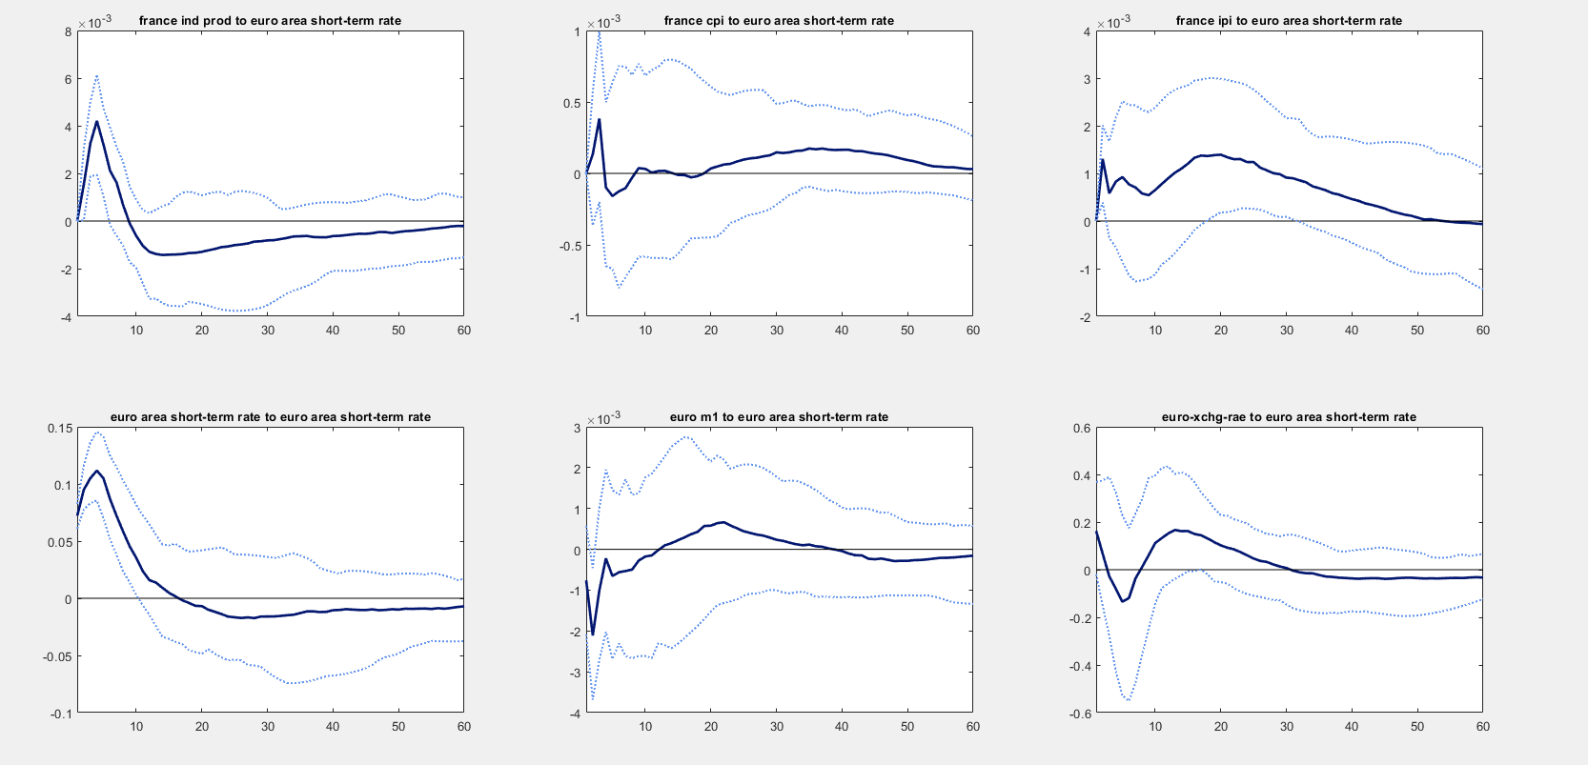Interpretation of Results

Figure 1: Impulse responses of France’s macroeconomic variables to a euro area monetary shock. From top left to bottom right: industrial production, cpi, import prices, euro area short-term rate, euro area M1, euro area exchange rate.

Using our SVAR models, we obtain impulse responses which describe the impact of a one-standard deviation of the short-term rate, on the national industrial production, consumer and import prices. Reactions of monetary aggregates and exchange rates are also displayed. As we compare the impulse responses of France to those of Germany, we note a relatively homogeneous response of industrial production to the ECB monetary shock (cf. figure1 and figure 2). We observe that the maximum semi- elasticity of output to the monetary shock is about 0.4% in France and 0.6% in Germany. Magnitudes are hence relatively similar. The impulse response of industrial production also seems to display a comparable reaction over time in both countries. On impact, the industrial production experience a sharp increase. According to the conventional story, this can be interpreted as follows: an increase in the short-term rates, as it raises the cost of short-term debt, also conducts productive agents to anticipate for future increase in the cost of capital. This can paradoxically lead to an increase in inventory stocks, and a positive bump in industrial production in the short term. In both countries, industrial production begins to fall 10 to 20 months after the monetary shock was conducted. In fact, both the increase in interest expenses and the reduction in demand progressively increase capital costs while cutting down corporate incomes, leading firms to clear inventories and to reduce output. Part of those results are analogous to what Dedola and Lippi observe at an aggregate level. However, the bump in industrial production displayed by our impulse responses seems abnormally persistent and strong, in comparison to the common findings in the literature. Concerning the reaction of prices in both countries, the impulse responses we obtain are somewhat erratic. France and Germany’s import prices react quite differently, which might account for differences in trading characteristics between both countries. Consumer prices display no clear pattern in both countries, and seam to poorly react to the shock on the Euro area short term rate. This might illustrate the price puzzle the euro area has been experiencing over the past decade, where growth rates of consumer prices have seemed to be inelastic to expansive monetary policies. Hence, it is most likely that this overall lack of interpretability (notably in comparison to the results obtained by Dedola and Lippi) might be related to our period of study.

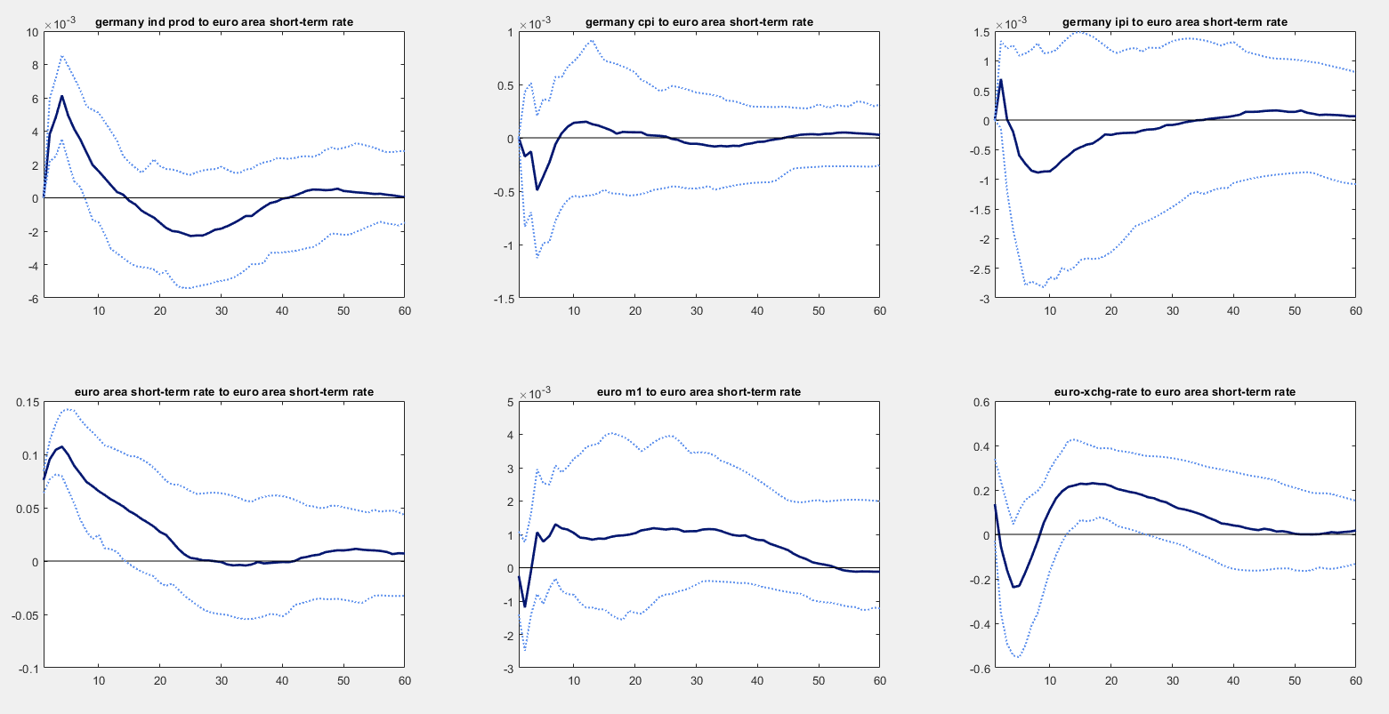Nonetheless, despite the many puzzles we encounter from our impulse responses, we feel that the homogeneity displayed notably in the industrial production’s response for France and Germany is a clue that adopting the monetary policy at a euro area level has not led to stark cross-country heterogenous responses to monetary shocks in the euro area. That is not to say that we believe that monetary policy lead by ECB identically impacts countries in the euro zone. We simply hypothesize that at an aggregate level, the exogeneous component of the monetary policy lead by the ECB seems to impact relatively homogenously cross-country aggregates (at least for France and Germany). Lastly, adding to the picture, the impulse responses of the US (cf. figure 3), seems to corroborate, or at least not discredit, the results obtained by Dedola and Lippi about the homogeneity of cross-country responses to monetary shock between OECD countries.

Figure 2: Impulse responses of Germany's macroeconomic variable to a euro area monetary shock

Finally, we find that using aggregated data level, we are quite forced to acknowledge that monetary shocks seem to produce relatively homogeneous cross-country responses among economically comparable countries. Our enquiry about the effect of a supra national monetary shock on the industrial outputs of countries in the euro area produced “results” again supporting the homogeneity in cross-country responses to monetary shocks. We are aware of the tremendous lack of robustness of our analysis. Our period of study (2004-2020) has been characterized by substantial evolutions in the implementation of monetary policies, which likely changed how monetary shocks impact the real economy. A way to improve our analysis would possibly be to divide our work into two subperiods. First studying the 2004-2008 period during which the FED as well as the ECB were still relying on the conventional manipulation of short-term rates through OMOs (Open Market Operations) and for which the standard VAR models we used seem appropriate, then looking at the time period 2008-2020. In fact, since the great recession, enduringly low nominal short term interest rates close to the zero-lower bound, have apparently weakened the monetary transmission effect, requiring the usage of unconventional monetary policies such as Quantitative Easing (equivalent to implementing large-scale OMOs, no longer restricted to T-bills, but opened to a large pool of assets). This suggests that for our second time period (2008-2020), using standard SVARs models might be insufficient in assessing the impact of monetary policy shock on the economy. Therefore, we would consider applying a similar method used by Meinusch and Tillmann (2016) where standard SVAR model is extended with some binary variable 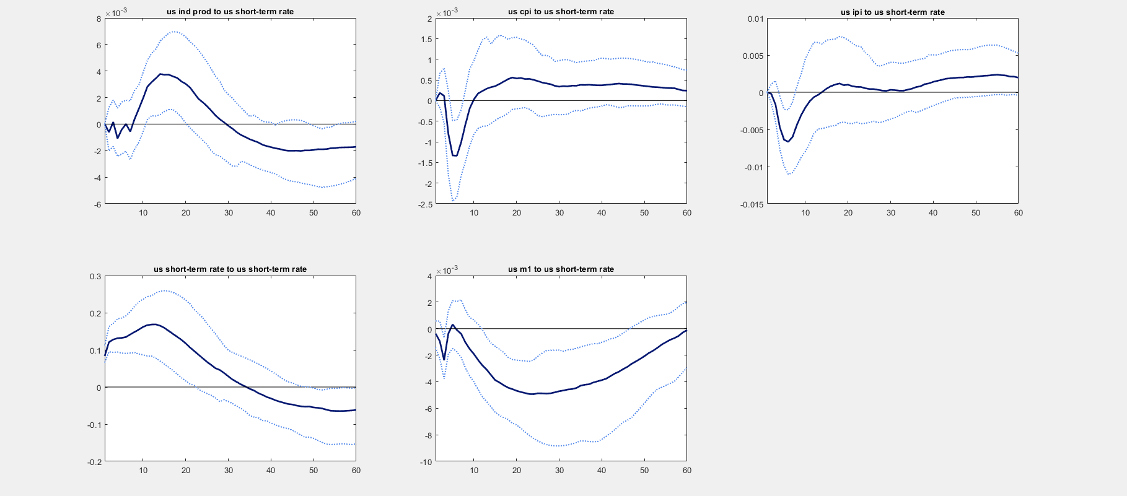tracing information about QE announcements.

Figure 3: Impulse responses of US macroeconomic variables to a us monetary shock. From top left to bottom right: industrial production, cpi, import prices, us short-term rate, us M1.

## Conclusion

We can draw two central claims from analyzing Dedola and Lippi (2005), as well as from reflecting on our empirical quantitative work.

Firstly, the analysis of monetary policy at an aggregated level displays substantial cross-country homogeneity. Our empirical work fails to reject such phenomenon. Studying the impact of supra national monetary shocks in the euro area, we observe relatively comparable output reactions in France and Germany. When we do apples-to-apples country comparisons we seem to obtain apples-to-apples monetary reactions. However, staying at this aggregated level means renouncing to fully understand the inner workings of monetary policy transmission, which brings us to the second crucial claim we want to stress. Using micro data level is key in assessing the economic impacts of monetary shocks. In fact, what Dedola and Lippi observed is that the cross-sectorial responses to monetary shock are quite substantially different, implying some significant redistributive effects. This results from the multiple mechanisms that lie in the various channels of monetary transmission. An extensive literature has flourished, since 2004 and the publication of this paper, studying the redistributive impact of monetary policy on the supply and demand side. A recent paper, published by ECB economists in March 2020, studies the impact of monetary policy on regional inequality inside the euro area, using precisely “granular data on economic activity at the city and county level in Europe”. The authors show that “output response to monetary shock is stronger and more persistent in poorer regions” concluding that “policy tightening aggravates regional inequality and policy easing mitigates it.”. The stakes that the ECB face in implementing supra national monetary policies are hence tremendously bigger than what our aggregated level analysis led to believe.

Finally, if the recent literature has well capitalized on the usage of micro level data to disentangle the true cause and effect of macroeconomic policy, and specifically monetary policy, much further research is still needed to understand the monetary transmission effect and how it impacts economies. A typical question which we feel is yet mostly unanswered is the assessment of the distributional effects of the new unconventional tools of monetary policy, which require more complex modeling.

N.B. Data collection

The data we worked with was mostly collected using the FRED API (Application Programming Interface). We implemented a python script (*fred_api.py*) which makes some calls to the server of the FRED® Economic Data database and returns macroeconomic time series under .xlsx format. We have designed this script to be re-usable for further research work requiring macroeconomic data available on the FRED® Economic Data database.

We collected data from the following sources:

* Economic Indicators – complete database”, Main Economic Indicators (database) Copyright © 2016, OECD, retrieved from FRED, Federal Reserve Bank of St. Louis; <https://fred.stlouisfed.org/series>
* International Monetary Fund, Copyright © 2016, retrieved from FRED, Federal Reserve Bank of St. Louis; <https://fred.stlouisfed.org/series>

# References

Bernanke, Gertler. "Inside the black box: the credit channel of monetary policy transmission." *NBER*, 1995.

Dedola, Lippi. "The monetary transmission mechanism: Evidence from the industries of five OECD countries." *European economic review*, 2005.

Friedman, Schwartz. "A monetary history of the United States." *Princeton University Press*, 1963.

Hauptmeier, Holm-Hadulla, Nikalexi. "Monetary policy and regional inequality." *Working paper ECB*, 2020.

Meinusch, Tillmann. "The macroeconomic impact of unconventional monetary policy shocks." *Journal of Macroeconomics*, 2016.